

GOKHALE EDUCATION SOCITY’S

R.N.C. ARTS, J.D.B. COMMERCE & N.S.C. SCIENCE COLLEGE.

--------------------------------------------------------------------------------------------------------------------------------------------------------

***Department Of Computer Application***

Title of the Project

***“ virtual mouse ”***

**GUIDE BY: SUBMMITED BY:**

Prof.varsha joshi Ruikar Ishwari ,47

Sharma Arju ,52

**Head of department :**

Prof.L.H.KINAGE

# **CERTIFICATE**

This is to certify that,

Miss.**ISHWARI RUIKAR &** Miss.**ARJU SHARMA**

of T.Y.BBA(CA)

have satisfactorily completed the project work on the topic

“**VIRTUAL MOUSE "**

In partial fulfillment for The degree of Master of Computer Science in the academic year

**2023-2024**

As per the requirements of the

**Savitribai Phule University of Pune**.

**Prof. L. H. Kinage**

Head of department.

DATE :

Internal Examiner External Examiner

# **Index**

Contents

Title of project 1

**C E R T I F I C A T E** 2

**Index** 3

**Acknowledgement** 4

**Abstract** 5

**Introduction** 6

**Problem Definition** 7

**Scope of Project** 8

**System Design** 13

**Hardware requirements** 18

**Software requirements** 19

**ER diagram** 20

**UML Diagrams** 21

**Sample code** 28

**Input output screen** 33

**Limitations** 34

**Conclusion** 36

# **Acknowledgement**

We own our sincere gratitude to all those people who have given us their constant support and encouragement without which our project report would not have reached this stage. We would like to express our thanks to Varsha Joshi mam For her advice and encouragement. She has been pillar of strength right through the project till the preparation of this report and helped by boosting moral, so we could surmount the difficulties that came across during completion of this project. We would like to express our gratitude to Dr. Manjusha Kulkarni Principal of R.N.C Arts, J.D.B Commerce & N.S.C Science College. Special thanks to Prof.L.H.Kinage , Head of computer science department for the support and the infrastructure they have provide, so that we could successfully complete the project on time.Last but not the list we would like to express our sincere thanks to all staff members and our friends for their help and cooperation in all phases of the project.

# 

# **Abstract**

The Al Virtual Mouse uses computer vision techniques to track hand movements and translates them into cursor movements on the screen. The system is designed to be intuitive and user-friendly, allowing users to interact with their computer without the need for a physical mouse. The virtual mouse is developed using Python and OpenCV libraries. The project includes the implementation of various image processing algorithms, such as hand segmentation, feature extraction, and classification. Moreover, it is robust to various lighting conditions, backgrounds, and hand sizes. The developed system provides an alternative to conventional mouse devices, particularly for individuals with disabilities or those who prefer a more natural way of interacting with their computers. The target of this project is the invention of something new in the world of technology that helps an individual work without the help of a physical mouse. It will save the user money and time. Real-time images will be continuously collected by the Virtual Mouse color recognition program and put through a number of filters and conversions. When the procedure is finished, the program will use an image processing technique to extract the coordinates for the position of the desired colors from the converted frames. The virtual mouse system is evaluated on various metrics, such as accuracy, speed, and robustness, and compared with existing virtual mouse systems. The trial findings demonstrated a high degree of accuracy 97.37%; the system can operate well in actual scenarios with just one CPU. Following that, it will compare the current color schemes within the frames to a list of color combinations, where various combinations correspond to various mouse operations

# **Introduction**

In computer jargon, a computer mouse is a directing device that recognizes two dimensional motions in respect to a surface. This movement is converted into the movement of the cursor on a display in order to manipulate the GUI, or Graphical User Interface, on a computer platform. It's difficult to fathom living in our high-tech day without computers. Another of the greatest innovations ever made by humans is the computer. For people of all ages, using a computer has become a necessity in practically every aspect of daily life. We frequently use computers in daily life to facilitate our job. Consequently, by enhancing movement accuracy with even the smallest hand movements. No matter how precise a mouse is, however, there are still physical and technical constraints that must be considered. Since the release of a mobile device with touch screen technology, people have begun to demand that the same technology be used on all other technological devices, including desktop computers. Although touch screen technology for desktop computers already exists, the cost can be prohibitive. In this project, a finger tracking-based virtual mouse application will be designed and implemented using a regular webcam. To implement this, we will be using the object tracking concept of Artificial Intelligence and the OpenCV module of Python. Therefore, an alternative to the touch screen could be a virtual human computer interaction device that uses a webcam or other image capturing devices to replace the actual mouse and keyboard. A software program will continuously use the webcam to track the user's gestures, process them, and translate them into the motion of a pointer, much like physical mouse.

# **Problem Definition**

The proposed AI virtual mouse system can be used to overcome problems in the real world such as situations where there is no space to use a physical mouse and also for the persons who have problems in their hands and are not able to control a physical mouse. Also, amidst of the COVID-19 situation, it is not safe to use the devices by touching them because it may result in a possible situation of spread of the virus by touching the devices, so the proposed AI virtual mouse can be used to overcome these problems since hand gesture and hand Tip detection is used to control the PC mouse functions by using a webcam or a built-in camera. The following describes the general problem that the current physical mouse suffers

# **Scope of Project**

The scope of this project is to develop a virtual mouse that will be operated without touching any device or screen. In today’s world where we are adjusting our living while being in a pandemic, a touch less mouse controller will be useful to eliminate the risk of spreading infection through touch on public service

devices. A virtual mouse will be introduced soon to replace the physical computer mouse in order to promote convenience while still allowing accurate interaction and control of the computer system. The virtual mouse can be used without touching the screen. This project can improve the scope of Human Computer Interaction technology to be explored more.

It is safe to predict that the Virtual the Mouse will soon take the place of the conventional physical in nature mouse in the not-too-distant future, as people strive to live in a world where every technological appliance can be operated and interacted with remotely without the need for any peripheral devices, such as remote controls, keyboards, etc. Not only does it offer ease, but it also saves money

* **User-Friendly**

Man-made consciousness has different applications in the present society. It is becoming fundamental for the present time since it can take care of complicated issues with an effective way in various ventures, like Health care, diversion, finance, schooling, and so forth Computer based intelligence is making our everyday existence more agreeable and quicker. It is well known that users must utilize a physical mouse in order to communicate with the computer system. This mouse requires a specific area of surface to work in addition to having cable length restrictions. Virtual Mouse doesn't need any of that since all that is needed is a camera to take pictures of the user's hand position and utilize those images to establish where the points should

* **Cost effective**

An Al virtual mouse, also known as a software-based mouse or an on-screen mouse, can be cost effective compared to a physical mouse for a few reasons:

1. **Accessibility:** A virtual mouse can be used by individuals who may have difficulty using a physical mouse due to physical limitations, such as a disability.
2. **Compatibility:** A virtual mouse is typically compatible with most computer systems, regardless of the hardware or operating system being used.
3. **Ease of use:** A virtual mouse is typically easy to use and requires minimal training. Hand Tracking: Implement hand tracking using computer vision libraries such as OpenCV to detect and track the user's hand movements.
4. **Cursor Control:** Translate the detected hand movements into cursor movements on the screen. Allow users to move the virtual mouse cursor in two dimensions (x and y) by controlling the position of their hand.
5. **Click and Drag:** Enable users to perform mouse clicks and drag actions using hand gestures. Implement different gestures to mimic left-click, right-click, and drag operations.
6. **Gestural Commands:** Introduce gestural commands for additional functionalities, such as scrolling, zooming, or switching between applications.
7. **User Interface:** Develop a graphical user interface (GUI) to display the virtual mouse cursor's position and provide visual feedback for hand gestures and interactions.
8. **Compatibility:** Ensure compatibility with various operating systems (Windows, macOS, Linux) and screen resolutions.
9. **Performance Optimization:** Optimize the software application for real-time performance to minimize latency between hand movements and cursor actions.
10. **Documentation and Support:** Provide comprehensive documentation and user guides to help users set up and use the virtual mouse application effectively. Offer technical support channels for troubleshooting and assistance.

* **Constraints**

1. **Hardware Limitations:** Consider the limitations of the hardware used for hand tracking (e.g., webcams or depth sensors) and ensure compatibility and performance optimization.
2. **Accuracy and Reliability:** Strive for accurate and reliable hand tracking and gesture recognition to provide a seamless user experience.
3. **Privacy and Security:** Address privacy concerns related to capturing and processing video data for hand tracking. Implement security measures to protect user data and prevent unauthorized access.
4. **Resource Utilization:** Optimize resource utilization (CPU, memory, etc.) to ensure the virtual mouse application runs smoothly on various hardware configurations.
5. **Multi-Hand Support:** Extend the virtual mouse functionality to support tracking and controlling multiple hands simultaneously.
6. **Gesture Customization:** Allow users to customize and define their own gestures for specific actions or commands.
7. **Integration with Existing Software:** Enable integration with existing software applications, particularly those designed for accessibility purposes.
8. **Machine Learning Integration:** Explore the use of machine learning techniques to improve hand tracking accuracy and gesture recognition capabilities.
9. **Mobile Compatibility:** Develop a mobile version of the virtual mouse application for smartphones and tablets, leveraging built-in cameras for hand tracking.

# **System Design**

There are two main steps in the process of color recognition: the calibration phase and the recognition phase. In the calibration phase, which will be utilized later in the recognition phase, the system will be able to identify the Hue Saturation Values of the colors selected by the users. It will save the parameters and settings into text documents for later use. The system will begin to take frames during the recognition phase and look for color input based on the values that have been stored during the calibration process phase. The following figure depicts the stages of the virtual mouse:

**Recognition Phase**

**a) Webcam and variable initialization:**

Early in the recognition phase, the software will initialize the necessary variables that will be used to store various frame kinds and value ranges, each of which will be used to complete a specific task. Additionally, during this phase, the program gathers the calibrated HSV values and settings that will be applied later during the Binary Threshold transitions.

**b) Real Time Image Acquisition:**

Using (cv: Video Capture cap (0)), the real-time picture is taken using the camera. Each image is placed into a frame variable (cv: Mat), which is then flipped and compressed to a manageable size to lessen process load.

**c) Frame noise Filtering:**

The noise in the collected frames will be reduced using Gaussian filters, just like it was done during the calibration step.

**d) HSV frame transition:**

It is necessary to change the captured frame's format from BGR to HSV.

**e) Binary Threshold Transition:**

A range check will be performed on the converted HSV frame to see if the HSV values fall within the range of the HSV variables collected during the calibration step. The frame will be converted into the binary system Threshold as a consequence of the range check, with a portion of the frame being set to 255 (1 bit) if the frame falls within the given HSV values and to 0 (0 bit) otherwise.

**f) Binary Threshold Morphological Transmission:**

After obtaining the binary threshold, the frame will go through a procedure termed morphological conversion, which is a structural operation to get rid of any foreground gaps and tiny objects. Erosion and Dilation are two morphological operators that make up the transformation. In order to remove minor sounds, the Erosion operator works by eroding the foreground object's edges and reducing the area of the binary limit. In terms of dilation, it is the reverse of erosion and raises the binary threshold area, allowing an item that has been eroded to regain its former shape.

**g) Color Combination Comparison:**

The software will determine the remainder of the number of objects by highlighting them asblobs after collecting the results from the morphological transformation process; this procedure necessitates the use of the cvblob library, an OpenCV add-on. In order to identify how the mouse behaves according to the color configurations identified within the collected frames, the calculation's findings will then be sent for comparison.

**h) Colors’ Coordinates Acquisition:**

The program will display the general shape of each object that falls within the binary threshold where it will compute the shape's area and midpoint coordinates. The coordinates will be kept and utilized subsequently to execute different mouse operations based on the data gathered, either in setting cursor positions or in calculating the separation between each of the spots.

1. **Execution of Mouse Action:**

Based on the color combinations found in the processed frame, the application will carry out mouse operations. The mouse movements will be carried out in accordance with the coordinates that the software has supplied, and the application will keep acquiring and processing new real-time images up until the users depart it.

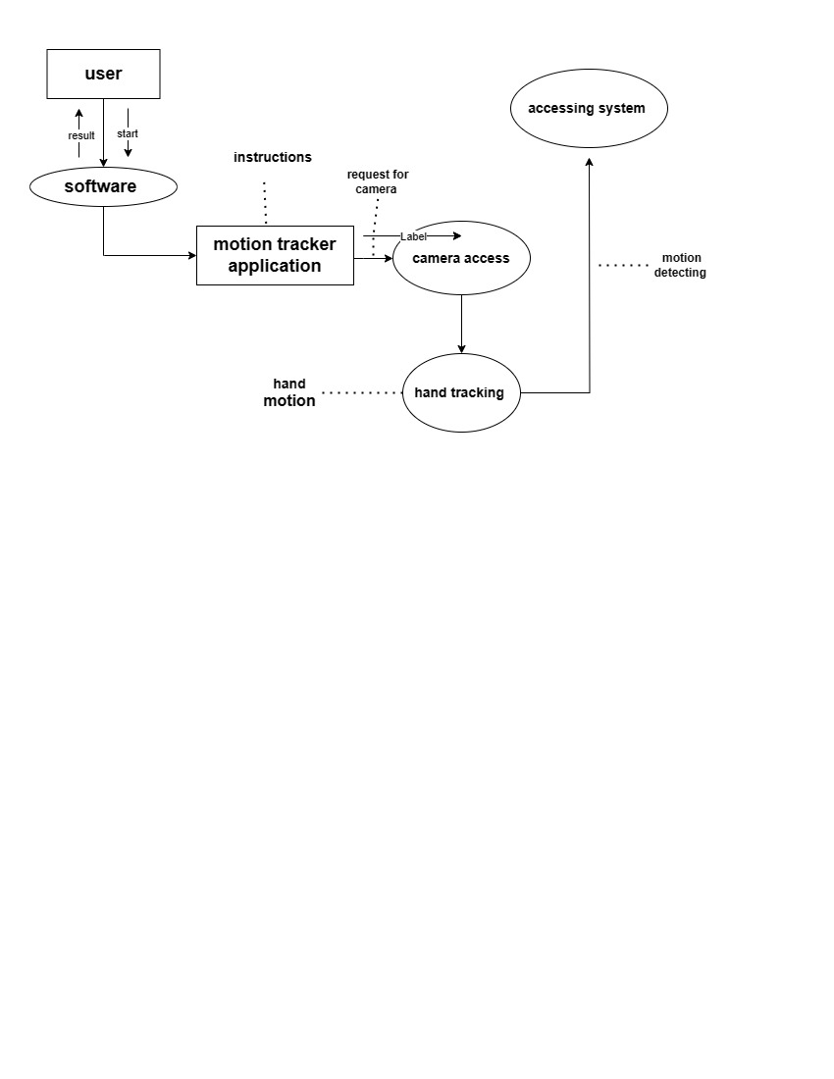

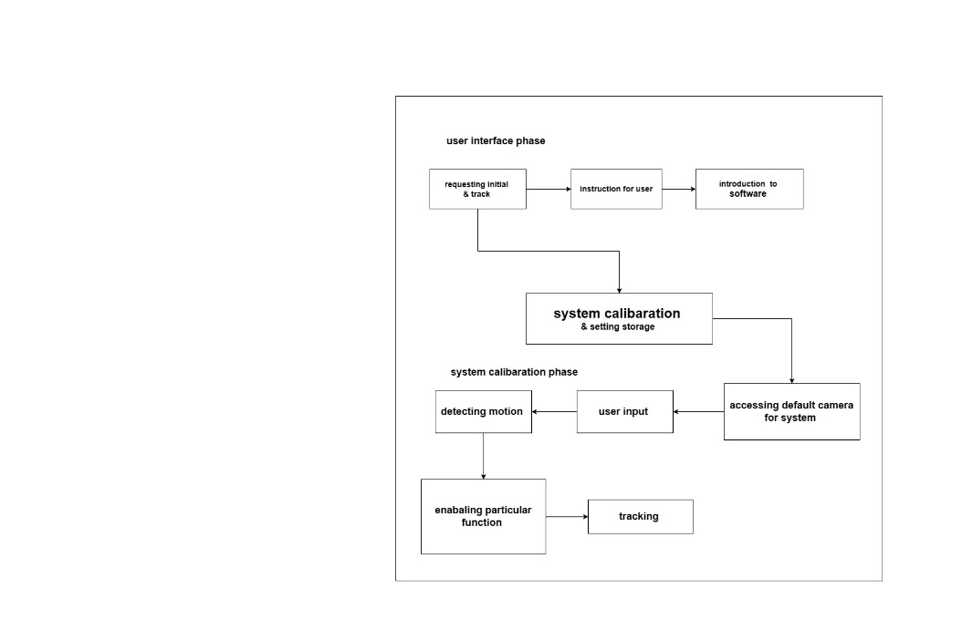**system design in block diagram**

# **Hardware requirements**

The hardware required to run and create the Virtual Mouse program is described below:

* **Computer desktop or laptop :** The machine such as a desktop or laptop will be used to run a visual program that will display what the camera captured. To promote mobility, a notebook, which is a tiny, lightweight, and affordable laptop computer, is offered.
* **System will be using :**

Processor : Core2Dual

Main Memory : 4GB RAM

Hard Disk : 320GB

Display : 14” Monitor

• **Webcam** **:** The use of a webcam for image processing allows the application to process images and determine the positions of individual pixels

# **Software requirements**

The following describe the software needed in order to develop the Virtual Mouse application

**• Python Language** **:** With the help of the Microsoft Visual Studio integrated development environment (IDE), which is used to create computer programs, the Virtual Mouse application will be coded using the python language. A python library offers many operators, including those for comparisons, logical operations, indirection, bit manipulation, and basic arithmetic.

• **Open CV Library :** Additionally, OpenCV was used in the development of this software. A collection of programming functions for real-time computer vision is called OpenCV (Open Source Computer Version). OpenCV has a tool that can read picture pixel values and can also make eye movement and blink recognition in real time.

* **Software will be using :**

Window 10 Ultimate 64-bit

Language : Python

* **Tool Used :** 1) open cv

2) mediapipe

3) num py

4) autopy

# **ER diagram**

# 

# **UML Diagrams**

1. **Motion tracking flow chart**

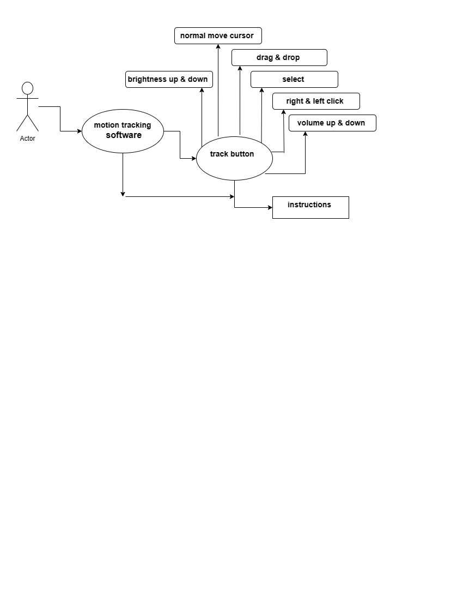

1. **Class diagram**

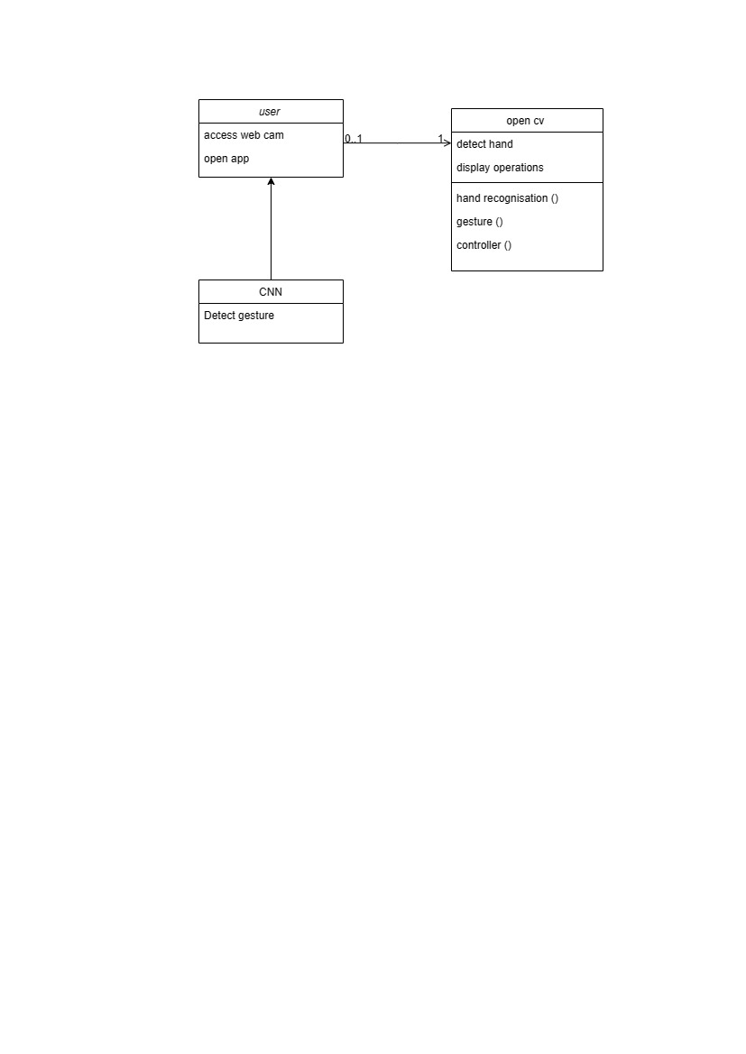

1. 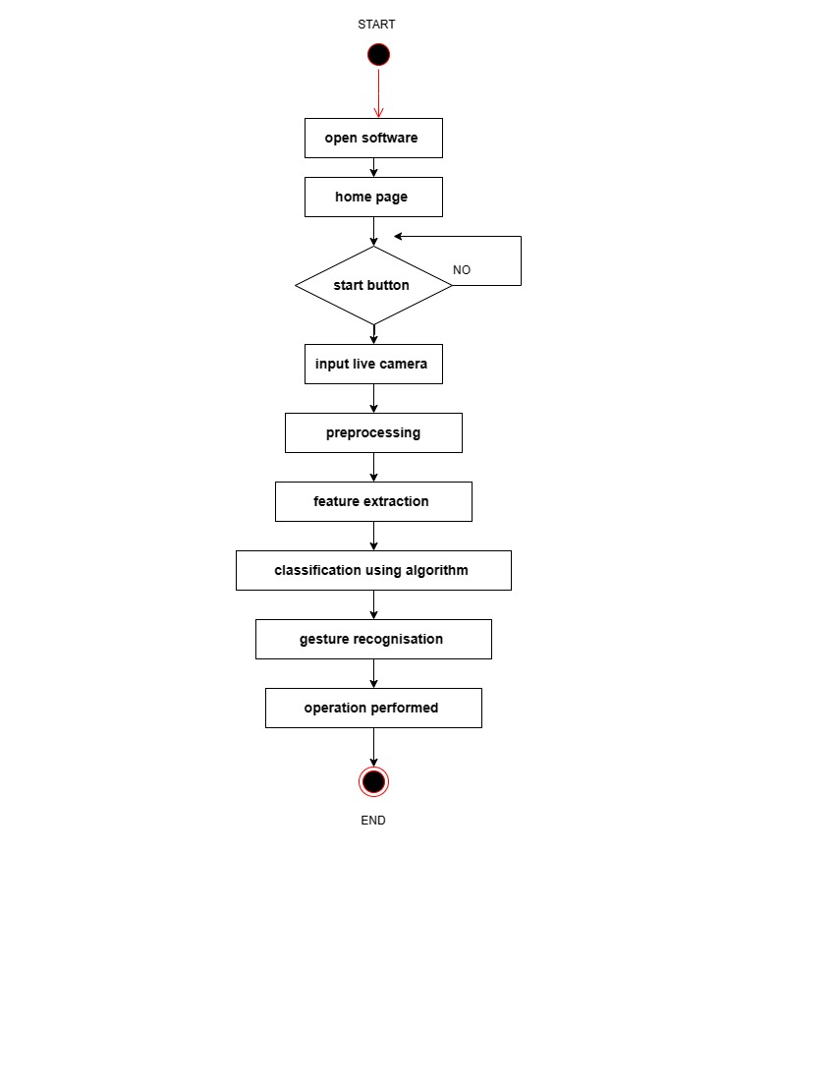**Activity diagram**

1. **Use case diagram**

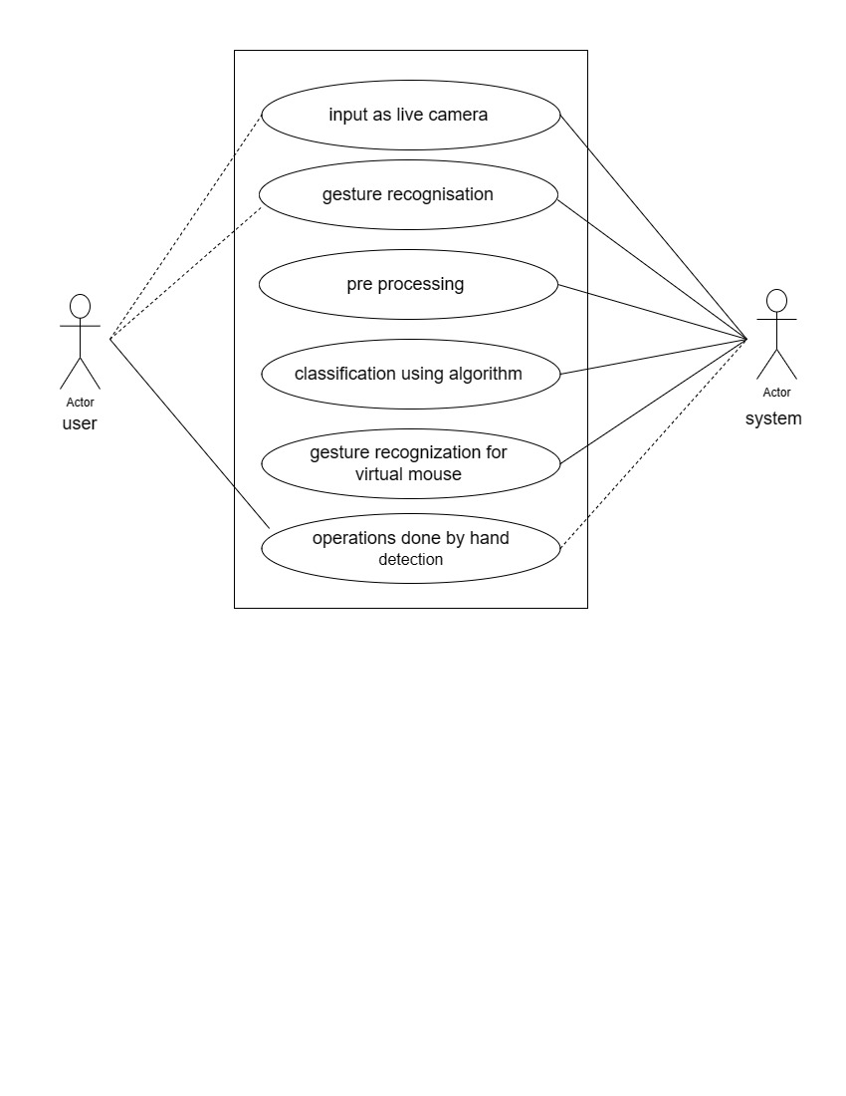

1. **Sequence diagram**

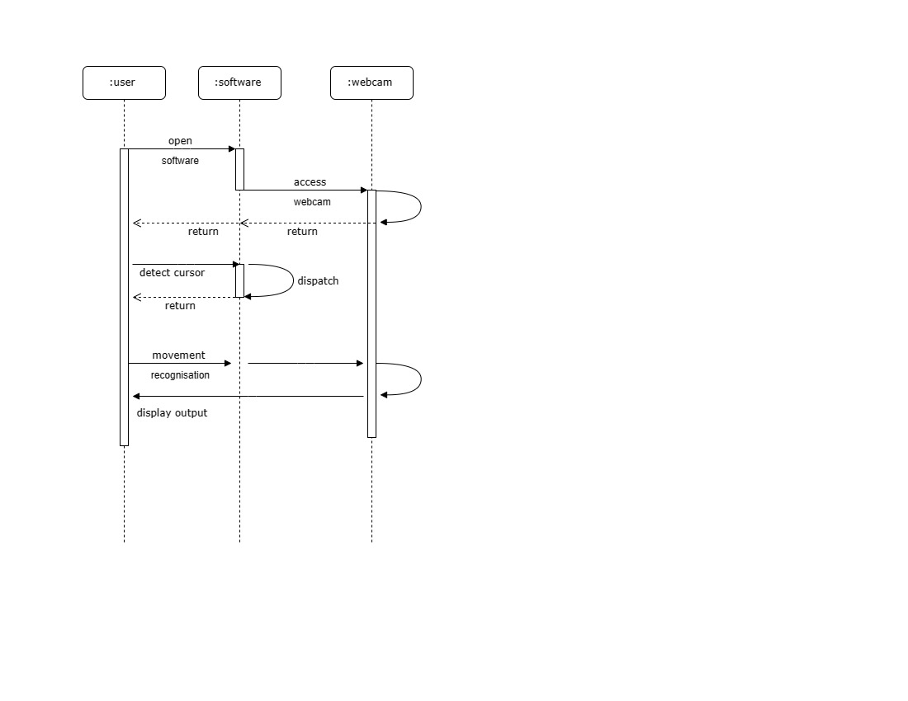

1. 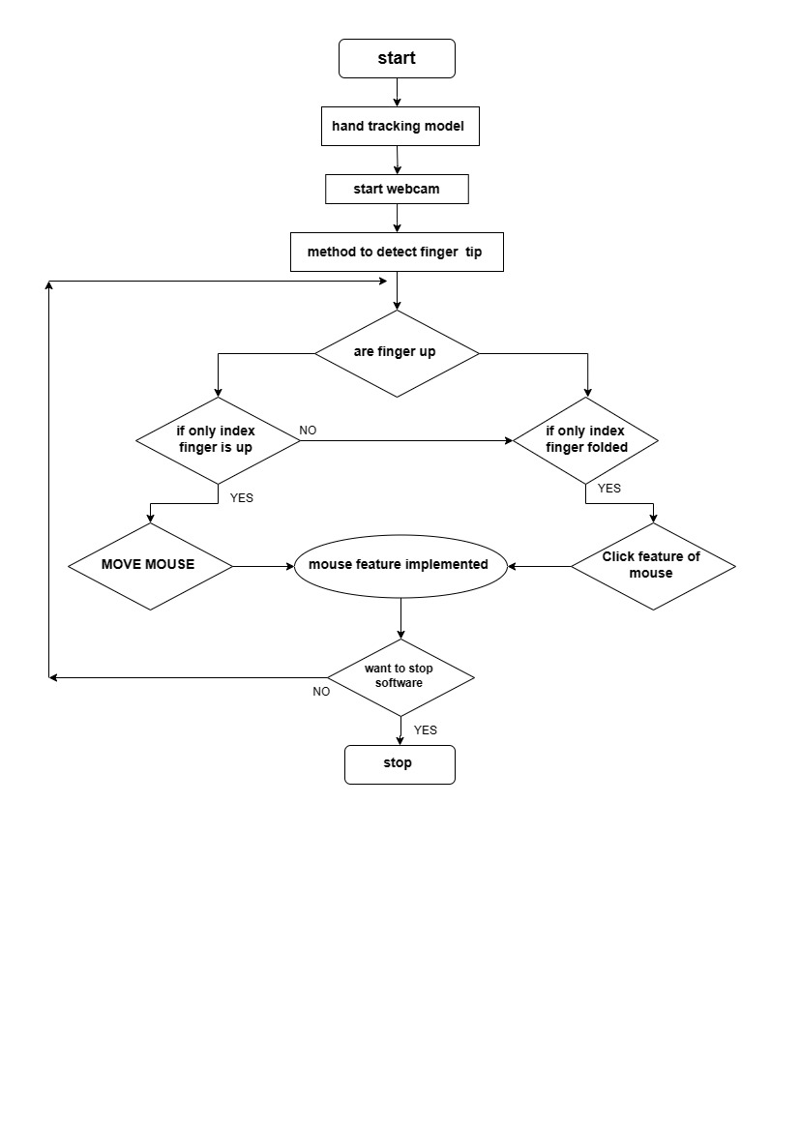**Flow diagram**
2. **Collaboration diagram**

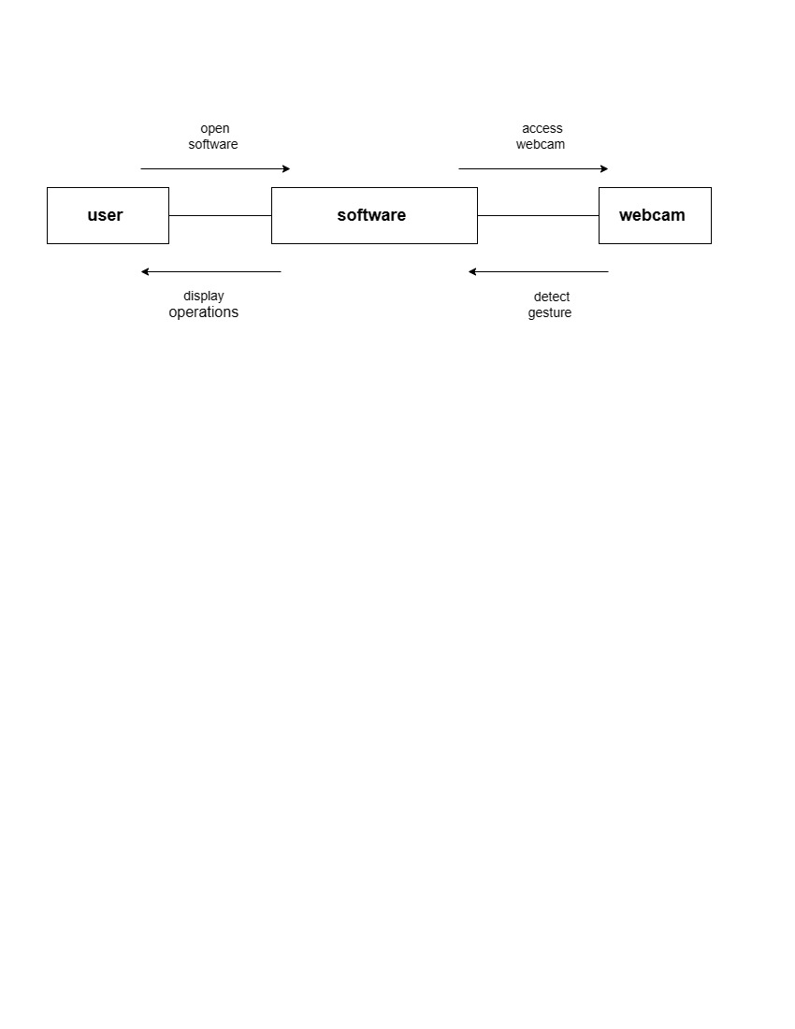

# **Sample code**

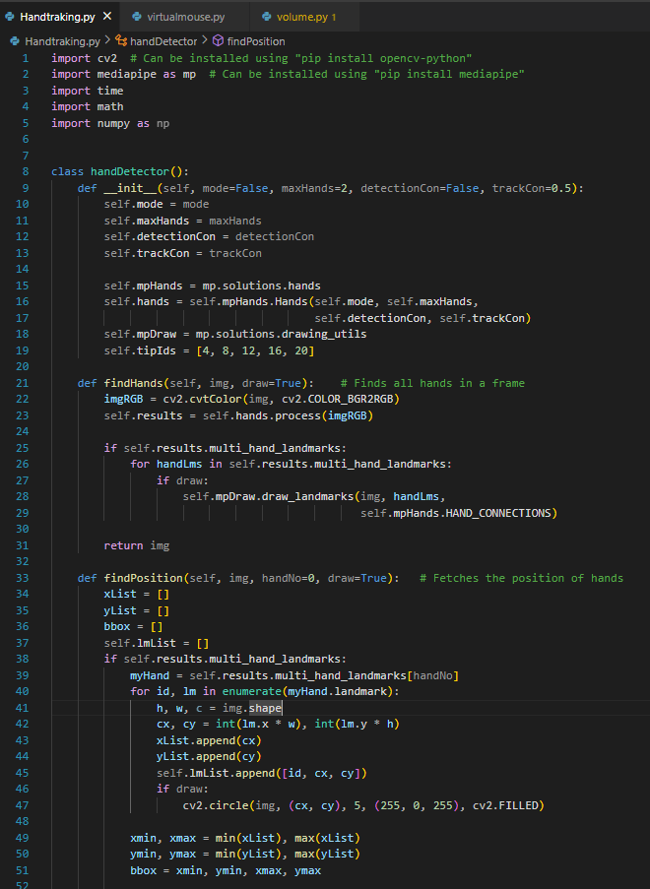

# 

# 

# 

# 

# **Input output screen**

# 

# 

# 

# 

# 

# **Limitations**

There are number of ongoing issues in this research that could impede the outcomes of color recognition. The environment aspect when the recognition phase is taking place is one of the issues. The recognition procedure is very sensitive to brightness levels since extreme intensity or blackness may make it impossible to see the targeted colors in the acquired frames. In addition, distance is another issue that could have an impact on outcomes of color identification. As the current detecting zone can only allow displays of color within limited radius. Any displays of colors beyond this limitation will be viewed as noise and filtered out

# **Conclusion**

The main objective of the AI virtual mouse system is to control the mouse cursor functions by using the hand gestures instead of using a physical mouse. AI virtual mouse system has performed very well and has a greater accuracy compared to the existing models and also the model overcomes most of the limitations of the existing systems. Since the proposed model has greater accuracy, the AI virtual mouse can be used for real-world applications, and also, it can be used to reduce the spread of COVID-19, since the proposed mouse system can be used virtually using hand gestures without using the traditional physical mouse. The model has some limitations such as small decrease in accuracy in right click mouse function and some difficulties in clicking and dragging to select the text. Hence, we will work next to overcome these limitations by improving the fingertip detection algorithm to produce more accurate results.